https://www.greatfrontend.com/questions/formats/ui-coding
https://dev.to/allenarduino/live-coding-react-interview-questions-2ndh

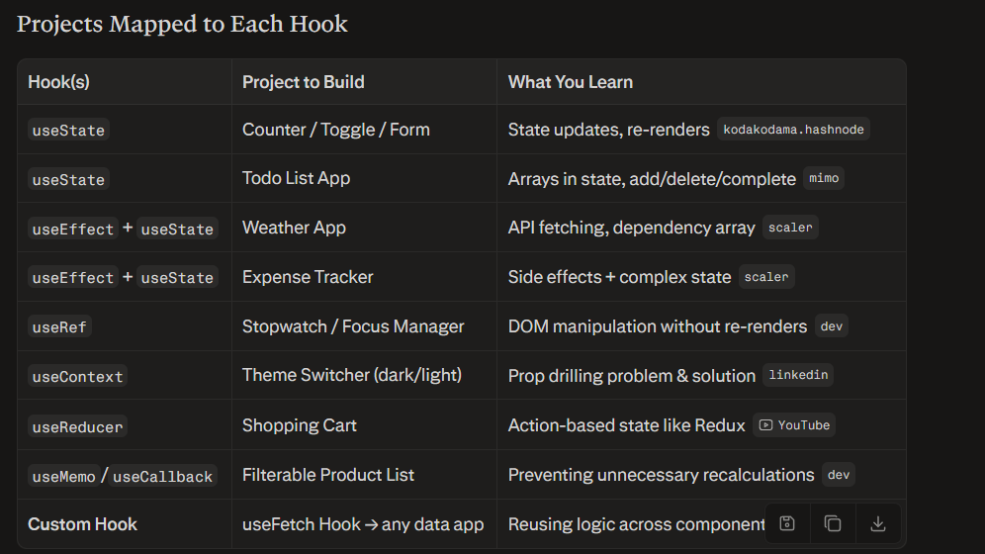

The most common React interview questions will have you fetch data, transform/process it, then display it.
Some other common React questions:
- Autocomplete/typeahead component
- Todo list
- Contact form
- Tabs component
- Star rating
- Image carousel
- Digital/analog clock
- File explorer
- Modal dialog
- Data table
Here is the complete list of most commonly asked React interview coding assessment projects, grouped by type:youtube+1reddit+2
Beginner-Level (Warm-up)
- Counter App (with undo/redo)
- Toggle Switch
- Calculator
- Temperature Converter
- Password Strength Checker
- OTP Input Component
- Digital / Analog Clock
- Quote Generator
- Theme Switcher (dark/light mode)
Component-Building Challenges
- Accordion Component
- Tabs Component (with keyboard interaction)
- Modal / Dialog Component
- Tooltip Component
- Star Rating Component
- Image Carousel / Slider
- Dropdown Menu
- Custom Checkbox / Radio Buttons
- Resizable Panel (Split Layout)
- Sticky Sidebar Component
- Horizontal Scroll Menu
- Animated Flip Card
Forms & Validation
- Multi-Step Form
- Dynamic Form (add/remove fields)
- Contact Form with Validation
- Inline Editable Input
- Form with Controlled Components
- Image Upload with Preview
Lists & Data Display
- Todo List App
- Pagination Table
- Sortable / Filterable Data Table
- Kanban Board (drag and drop)
- File Explorer (nested tree structure)
- JSON Diff Viewer
- Nested Comments / Threads
Search & Filtering
- Debounce Search with API Integration
- Autocomplete / Typeahead Search
- Search in Nested Structure
- Product List with Filter & Sort
API & Data Fetching
- Fetch & Display API Data (users, posts, etc.)
- Infinite Scroll
- GitHub User Search App
- Weather App (OpenWeatherMap API)
- Movie Search App (TMDB API)
- News Feed App
- Custom useFetch Hook
Intermediate Projects
- E-Commerce Product List with Cart (Context API)
- Image Gallery Viewer with Lightbox
- Sequential Progress Bar
- Real-time Character / Word Counter
- Stopwatch / Timer App
- Pomodoro Timer
Advanced / Take-Home Projects
- Kanban Board with Drag & Drop + Live Charts[reddit]​
- Full CRUD App with REST API
- Multi-level File Explorer
- Chat UI (with mock WebSocket)
- Dashboard with Charts (recharts / chart.js)
- Role-Based Protected Routes App
- URL Shortener Frontend
- Real-time Collaborative Todo (Firebase)
Utility / Logic-Heavy Challenges
- Flatten Nested Array / Object
- Deep Clone implementation
- Promise.all Polyfill with multiple API calls
- GroupBy Utility Function
- Close on Outside Click component
- useDebounce / useThrottle Custom Hook
- useLocalStorage Custom Hook

